# Task C: Functions

## 1. **Scalar Function: `fn_customer_lifetime_value(customer_id)`**     - Return total **paid** amount for the customer's delivered/shipped/placed (non-cancelled) orders.

**CREATE** **OR** **REPLACE** **FUNCTION** training_ecom.fn_customer_lifetime_value(p_customer_id **INT**)

**RETURNS** **NUMERIC** **AS** **$$**

**BEGIN**

**RETURN** (

**SELECT** **COALESCE**(**SUM**(p.amount), 0)

**FROM** training_ecom.payments p

**JOIN** training_ecom.orders o **ON** p.order_id = o.order_id

**WHERE** o.customer_id = p_customer_id

**AND** o.status **IN** ('placed', 'shipped', 'delivered')

);

**END**;

**$$** **LANGUAGE** plpgsql;

**SELECT** training_ecom.**fn_customer_lifetime_value**(1);

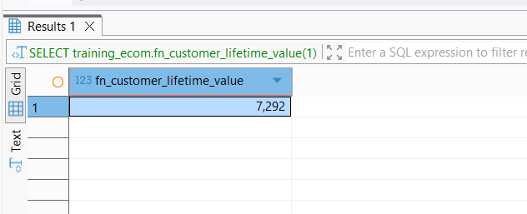

**2. **Table Function: `fn_recent_orders(p_days INT)`**  
    - Return `order_id, customer_id, order_date, status, order_total` for orders in the last `p_days` days.**

**CREATE** **OR** **REPLACE** **FUNCTION** training_ecom.fn_recent_orders(p_days **INT**)

**RETURNS** **TABLE** (

order_id **INT**,

customer_id **INT**,

order_date **TIMESTAMP**,

status **VARCHAR**,

order_total **NUMERIC**

) **AS** **$$**

**BEGIN**

**RETURN** QUERY

**SELECT**

o.order_id,

o.customer_id,

o.order_date,

o.status,

**SUM**(oi.quantity * oi.unit_price) **AS** order_total

**FROM** training_ecom.orders o

**JOIN** training_ecom.order_items oi **ON** o.order_id = oi.order_id

**WHERE** o.order_date >= CURRENT_DATE - **INTERVAL** '1 day' * p_days

**AND** o.status != 'cancelled'

**GROUP** **BY** o.order_id, o.customer_id, o.order_date, o.status;

**END**;

**$$** **LANGUAGE** plpgsql;

**SELECT** *

**FROM** training_ecom.**fn_recent_orders**(100);

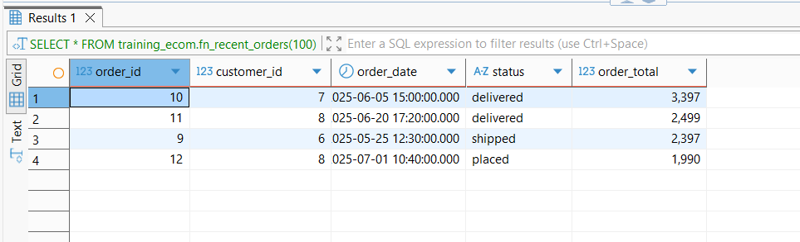

**3. **Utility Function: `fn_title_case_city(text)`**  
    - Return city name with first letter of each word capitalized (hint: split/upper/lower or use `initcap()` in PostgreSQL).**

**CREATE** **OR** **REPLACE** **FUNCTION** training_ecom.fn_title_case_city(p_city **TEXT**)

**RETURNS** **TEXT** **AS** **$$**

**BEGIN**

**RETURN** **initcap**(p_city);

**END**;

**$$** **LANGUAGE** plpgsql;

**SELECT** training_ecom.**fn_title_case_city**('kathmandu');

